Author Instructions
for the proceeding of the 4th Asian Conference on Molten Salt Chemistry and Technology/
44th Symposium on Molten Salt Chemistry, Japan

General information

- You must prepare your manuscript in ENGLISH under the file format of Microsoft Word. Adobe PDF files formed from the Word file must be also prepared. Please send the two files (Word and PDF) to the conference secretariat via e-mail (ams4@material.tohoku.ac.jp). Please check your manuscript carefully before the submission because you will not receive any proof.
- Do not apply any headers or footnotes, including page numbers.
- If you use any special font sets (Greek characters, ligatures, wingdings, etc.), you must embed your fonts within your manuscript.
- Do not password protect your document.
- Deadline of the proceeding submission is July 31.

Manuscript preparation

Template and sample manuscript
Download and check carefully the following template file and the sample manuscript file prior to the manuscript preparation.
Template.doc
Sample_manuscript.doc

Page size and layout
- Page size: A4 (210 x 297 mm).
- Margin settings: top 30 mm, bottom 30 mm, left 20 mm, and right 20 mm.
- The page length for ORAL presentation: 4 to 8 pages.
The page length for POSTER presentation: 2 pages.
- Line space: single.

Indenting
- Except for the abstract, indent the first line of each paragraph with five spaces.
- Leave two blank lines between sections such as “Introduction” and “Experimental”.

Type face and size
- For the title of the paper: Times New Roman, 14 point, boldface.
- For the author’s name, affiliation, abstract and body text: Times New Roman, 12 point.
- Check carefully and obey the detailed instruction for type face shown in the Template.doc.

Title, authors’ name, and affiliations
The tittle of the paper should be typed in boldface and centered on the page. The authors’ name should also be centered on the page. Under a blank line, place the affiliation with address and zip code, centered on the page.

Figure
Figures including graphs, line drawings, photographs and other illustrations should be in black and white only with sharp contrast. For microstructures and similar figures, be sure to place a scale marker on the photograph. Avoid the use of the boxes around the figures, as well as the use of the shaded background which do not reproduce well.
All figures should be consecutively numbered with Arabic numerals and inserted as close as possible to the corresponding text, preferably in the orientation shown below.

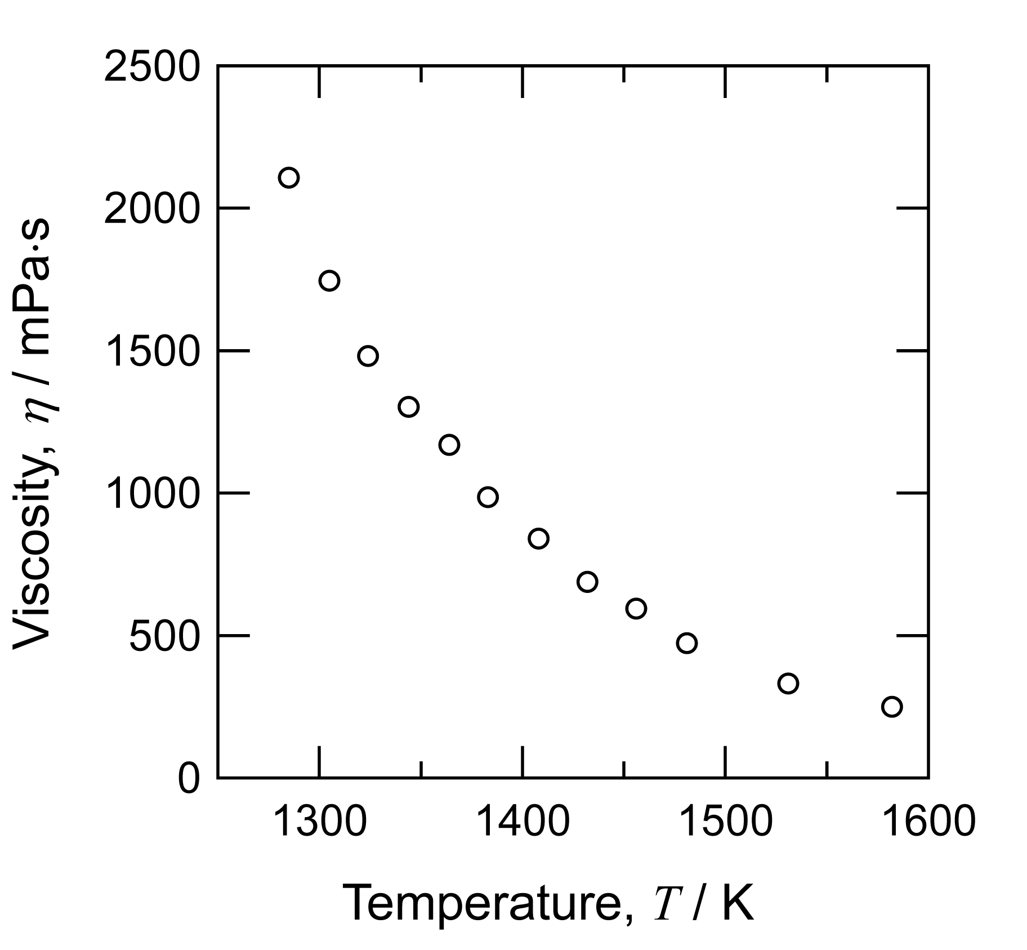
Fig. 1 Viscosity of molten SiO₂- 50mol% Na₂O.

A caption consisting of the word “Fig.” the figure number, and the figure title, in 12 point Times New Roman, should be appear centered below each figure.

Table
All tables must fit within the space allowed for text. All tables must be numbered consecutively with Arabic numerals, identified by a title, and cited (in order) within the text. The title should be typed above the table and centered as shown below.

Table 1 Font size in the manuscript
Category | Font size, S / point
Title | 14
Authors’ name, affiliation, abstract, body text | 12

Equations
All equations must be typed, centered, and separated from the text by two lines of space above and below the equation. They should be numbered consecutively throughout the paper, with the numbers appearing in round brackets at the right margin, in line with the last line of the equation (example shown below).
ΔGº =ΔHº − TΔSº (1)

Reference
Completed citations should appear at the end of the text. Use the reference style that is shown below for all references.

Examples of the format for book references
1)_I. Barin: Thermochemical Data of Pure Substances (1989, VCH Verlagsgesellschaft mbH, Weinheim, Germany).

Examples of the format for edited conference proceedings
6)_O. Takeda, M. Li, M. Hoshi and Y. Sato: Abstracts of 41th Symposium Molten Salt Chemistry, Japan, 41 (2009), 41-42.

Examples of the format for journal references
3)_T. Laude, T. Kobayashi and Y. Sato: International Journal of Hydrogen Energy, 35 (2010), 585-588.

Examples of the format for patent references
7)_D. Pal and K. Yost, “Fixation and Stabilization of Lead in Contaminated Soil and Solid Waste”, United States Patent, No. 5193936 (1993).

